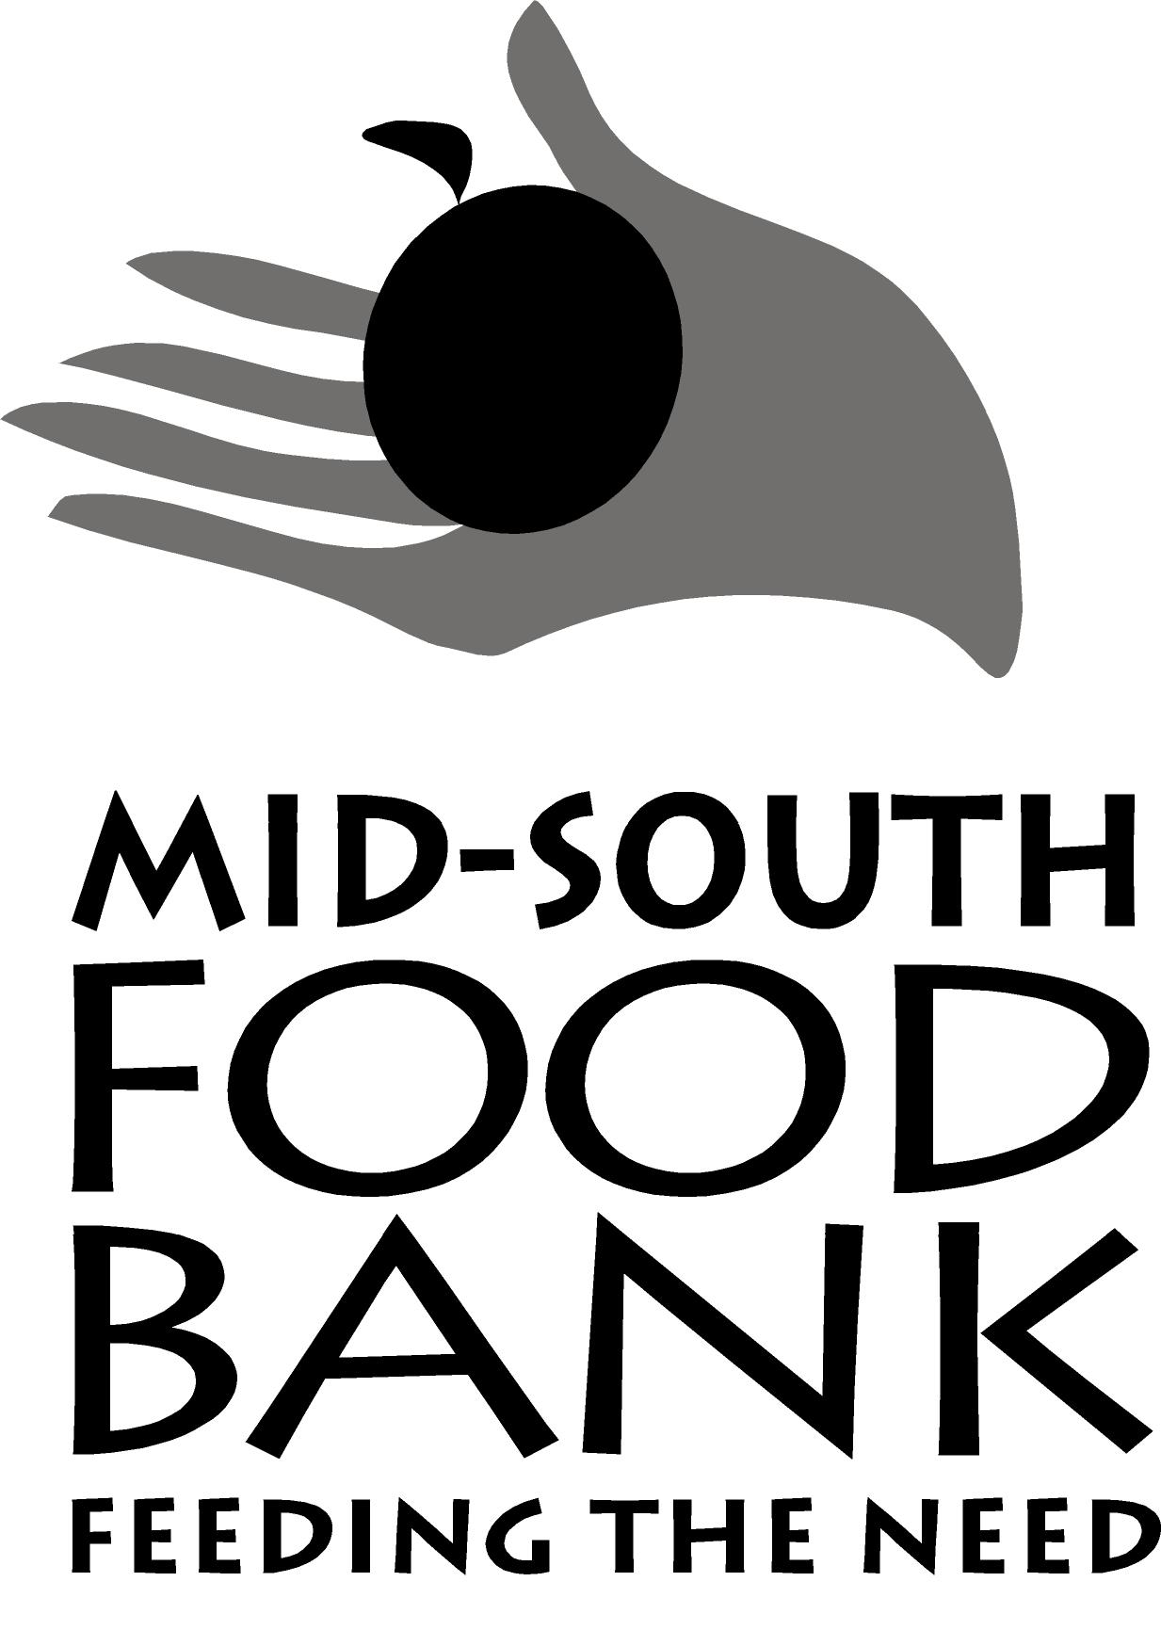
Client Eligibility Form

Name:

Address:

City: zip code:

phone number: CELL:

Please list all household members. If additional space is needed, list additional members on back.
Name (please print) | date of birth | gender | veteran  y/n
1. |  | MF
2. |  | MF
3. |  | MF
4. |  | MF
5. |  | MF
6. |  | MF
7. |  | MF
8. |  | MF
9. |  | MF
10. |  | MF

Please indicate emergency situation:

Please indicate client‘s proof of current participation. You must record the case number or document viewed below:

 Food Stamp Program (SNAP) ___________________________________________________________
 Temporary Assistance to Needy Families (TANF) ____________________________________________
 Supplemental Security Income ___________________________________________________________
 Residence in Public Housing ____________________________________________________________
 Low Income Home Energy Assistance Program _____________________________________________

If client does not have proof of participation in any of the above programs he or she must complete and sign a self-declaration income statement showing that the total amount of household income is below 150% (TN) or 130% (MS) of the current income poverty guidelines, using the income USDA Household Eligibility Scale.

~continue on back~

Check USDA Distribution Rate Used:
_X__ Monthly
____ Bi-Monthly
____ Quarterly

If this form is also used to determine eligibility, an applicant may self-declare income or show proof of participation in one of the following means-tested programs: SNAP (Food Stamps), Families First (FF), Supplemental Security Income (SSI), Low Income Home Energy Assistance Program (LP), or documented residence in public housing (PH).

AGENCY REP: If applicant shows proof of participation in one of the means-tested programs listed above, the agency rep should write code in appropriate column using one of the following Program Codes: SNAP, FF, SSI, LP, or PH.

Total Household Income: $_____________________ Yearly Monthly Weekly

Privacy Policy Summary
1. Reading this Summary document is not a substitute for reading the PantryTrak Privacy Policy in full.
2. Food banks, food pantries, and other service providers that use the PantryTrak System, have agreed to the terms of a Master Subscription Services Agreement that includes adherence to this Privacy Policy.
3. The Privacy Policy acknowledges that Personal Data is being collected in conjunction with your request for service.
4. Personal Data may include, but is not limited to: (a) first and last name, (b) home address, (c) date of birth and/or age (d) email address, (e) mobile and/or home phone number, (f) income information, (g) employment information, and (h) family, household, and/or dependent information.
5. Personal Data will not be sold for direct marketing purposes.
6. The Privacy Policy may change at any time; the most current version can be found at www.pantrytrak.com/privacy
I certify that the information and income listed is true and correct, that I received food assistance, and that no other member of my household has applied for and received food during this distribution. I understand that misrepresentation of need, or sale, or exchange of food is prohibited.

Signature of Head of Household Date

This program is available to all eligible recipients regardless of race, color, national origin, age, sex, sexual orientation, or handicap.

